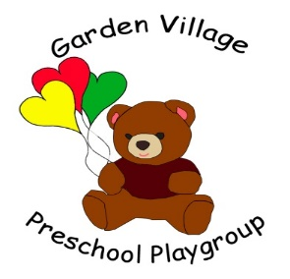

Welsh language policy and procedure

This policy has been developed for settings described as “predominantly English medium setting with some use of Welsh” and “English Medium Settings”. (For definitions of Welsh medium and bilingual settings see item 28.)
The Welsh Government has made a commitment to Iaith Pawb, the Government’s strategy for creating a bilingual Wales where English and Welsh are used equally.
For further information: http://new.wales.gov.uk/topics/welshlanguage and http://www.wcva-ids.org.uk/wcva/1114; and
http://www.byig-wlb.org.uk/english/Pages/index.aspx

It is the policy of Garden Village Pre-School to support children in our care to learn and use the Welsh language.
We do this by:
- Recognising that Welsh language development can be the starting point for children to begin to communicate in Welsh.

- Accessing information and help from the Welsh Language Board.

- Including the Welsh language in developing understanding of Welsh culture, feelings of belonging and a sense of heritage, roots and community with children in our care.

- Understanding that Welsh language development can provide additional social and cultural opportunities in later life.

- Informing parent/carers of our commitment to Welsh language development and how this is reflected in the setting.

- Supporting staff to undertake Welsh language training opportunities.

- Considering applicants’ ability in the Welsh language when recruiting staff.

- Maintaining a range of adult resources and contact details of relevant individuals and organisations to support staff in promoting Welsh language development.

- Supporting the learning of Welsh, gradually and naturally, in a rich and lively environment, through firsthand experiences that are fun.

- Ensuring that learning is supportive and respected and that children’s and adults’ efforts are acknowledged and praised.

- Encouraging and promoting Welsh as an integral part of everyday activities and practice.

- Providing a range of resources and activities that include and support the development of the Welsh language and culture.

- Identifying members of staff who use Welsh.

- Encouraging a Welsh language ‘buddy system’ for staff.

- Encouraging parents/carers who speak Welsh to use it while visiting the provision.

- Ensuring that when advertising events locally, English and Welsh will be equal in terms of size, format, quality, clarity and prominence.

- Monitoring the contribution that the use of Welsh language makes in the provision and seeking ways to increase and improve it.

This Welsh language policy and procedure was passed for use in Garden Village Pre-School
On: 19th August, 2015
By: Beth Williams Position: Chair
Date of planned review: On or before the 19th August, 2016

I, (Staff member/volunteer), confirm that I have read and understood the above policy.

Print name Signature Date

________________ ___________________ ________________
________________ ___________________ ________________
________________ ___________________ ________________
________________ ___________________ ________________
________________ ___________________ ________________
________________ ___________________ ________________
________________ ___________________ ________________
________________ ___________________ ________________
________________ ___________________ ________________
________________ ___________________ ________________
________________ ___________________ ________________

