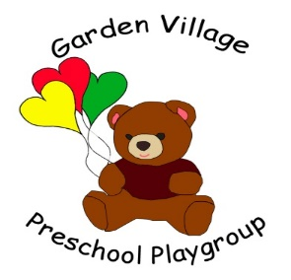

Looking after our environment policy and procedure
It is the policy of Garden Village Pre-School to:
- Appreciate and value our living world and our environment.
- Encourage and enable children in our care to develop their understanding of the living world and the impact we all have on it.
- Ensure our working practice supports the environment.
We do this by appreciating living things and learning about and respecting our local and wider community in the following ways:
- Children take part in planting and caring for plants (flowers and vegetables) both indoors and outside.
- Children help care for any animals kept at the provision, learning how to respect their needs and habits.
- Activities are planned to explore and reinforce the concept of caring for living things in our world.
- Adults are positive role models, showing their respect for living things in our world.
- Children are taken on walks in the immediate vicinity, where discussion is encouraged and follow-up activities (such as map making, documenting, and photography) are carried out.
- Children are encouraged to use litter and recycling bins inside and outside our premises and understand why.
- Children take part in tidying, clearing and cleaning activities as appropriate.
- Recycling is integral to the way we work with and dispose of equipment and resources.
- Children know that we recycle food waste and help maintain our compost bin, learning to understand its role in our provision and the wider community.
- Children learn that we use water carefully and how a lack of water affects the local and wider community.
- Children are included in decision making about what happens to equipment when it is no longer fit for them to use.
- Domestic strength, environmentally friendly substances such as washing up liquid, cleaning fluid, are used in the provision (please refer to our written risk assessment).

- Activities are planned to develop and nurture children’s natural curiosity about their location and the world around them, including cultural diversity (please refer to our equality and inclusion policy).
- Members of the local community (such as post people, police, fire service, farmers, etc) are invited to the provision to tell us about their roles and responsibilities, how they help us and how we can help them.
- Visits to shops, the fire station, farms, factories, municipal recycling area, library, and so on are undertaken.
- Garden Village Pre-School Playgroup commits to take part in local/national eco-friendly schemes as appropriate.

This looking after our environment policy and procedure was passed for use in Garden Village Pre-School
On: 19th August, 2015
By: Beth Williams Position: Chair
Date of planned review: On or before the 19th August, 2016

I, (Staff member/volunteer), confirm that I have read and understood the above policy.

Print name Signature Date

________________ ___________________ ________________
________________ ___________________ ________________
________________ ___________________ ________________
________________ ___________________ ________________
________________ ___________________ ________________
________________ ___________________ ________________
________________ ___________________ ________________
________________ ___________________ ________________
________________ ___________________ ________________
________________ ___________________ ________________
________________ ___________________ ________________

